Who Is My Mother?

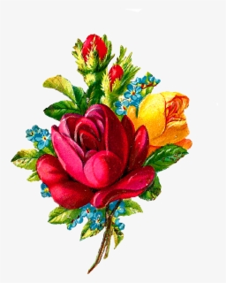

Matthew 12:46-50
⁴⁶ While Jesus was still talking to the crowd, his mother and brothers stood outside, wanting to speak to him. ⁴⁷ Someone told him, “Your mother and brothers are standing outside, wanting to speak to you.”
⁴⁸ He replied to him, “Who is my mother, and who are my brothers?” ⁴⁹ Pointing to his disciples, he said, “Here are my mother and my brothers. ⁵⁰ For whoever does the will of my Father in heaven is my brother and sister and mother.”

Here is a Scripture that is worth considering and the very question which Jesus puts to those who were gathered around him: Who is my mother…? Since it is Mother’s Day, I thought we should narrow down this question of Jesus with the focus on mothers. So, what about this question of Jesus? Have we considered that though we have our biological mother who raised and cared for us, that perhaps there have been other women in our lives, that, in a way, became our non-biological mothers? Clearly, this was Jesus’ thought in this reading. But notice how he states or defines what a mother means to Him: “…whoever does the will of my Father in heaven is my…mother.” Whether we have been raised by our biological mother or by she who is not our biological mother, holds no relevance with Jesus’ statement. The principle of motherhood for Jesus is based on “she who does the will of God.” We know that the greatest of God’s will is to love – to love God above all else, and to love our neighbor as ourselves. Therefore, in the Christian faith, as we choose to follow the teaching of Jesus Christ, true motherhood is defined by the love she has for God and others.

Happy Mother’s Day!
Rev. Wilbert Gamble, Pastor

